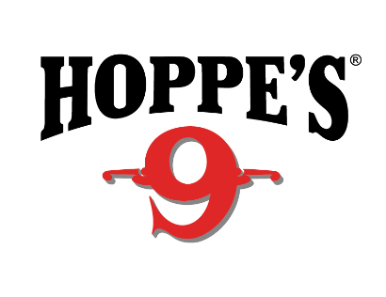 Contact: Kristen Veverka
Communications Manager
Tactical Products & Shooting Accessories
(913) 689-3630
FOR IMMEDIATE RELEASE E-mail: pressroom@vistaoutdoor.com

Hoppe’s Hosts Champion Shooters at 2018 NRA Show
OVERLAND PARK, Kansas (April 30, 2018) – Hoppe’s, the best known name in gun care products, will host top competitive shooters in the Vista Outdoor booth (#7530) at the 2018 National Rifle Association (NRA) Annual Meetings and Exhibits in Dallas, Texas, May 4-6. Show attendees will have the opportunity to meet world-class shooters Lena Miculek, Jessie Harrison, Missy Gilliland and John Scoutten.
Lena Miculek, the newest addition to the Hoppe’s Ambassador team, will be in the booth for a meet and greet May 4 from 2 p.m. to 3 p.m. Miculek is a professional shooter from Arkansas, who started shooting competitively at just 8 years old. Working as a full time professional competitive shooter for 6 years now, her past accomplishments include placing in the lady division at the NRA World Shooting Competition, IPSC Rifle World Shoot in Russia and High Lady at the USPSA Optic Nationals with PCC.
Recognized as one of the most accomplished competition shooters in the world, Jessie Harrison has won both world and national championship titles, including the Bianchi Cup and the Steel Challenge World Speed Shooting Championships. Harrison will be in the Hoppe’s booth May 5, from 1 p.m. to 2 p.m. and May 6 from 11 a.m. to 12 p.m.
Missy Gilliland, a well-known name throughout all shooting venues, will be in the booth on May 4 from 4 p.m. to 5 p.m. Gilliland boasts an impressive background, including qualifying as one of the Top 3 Females in Precision Rifle Series in both 2015 and 2016 Seasons, acting as co-host for seasons two through nine of Trigger Time TV and winner of numerous Precision Rifle Top Female awards
“Shooting USA” host and gun guru John Scoutten will be available to meet with show attendees on May 4 and 5 from 3 p.m. to 4 p.m. Scoutten interviews and participates alongside the best competitive shooters in the nation.
All attendees are encouraged to stop by booth #7530 to visit with their favorite shooting sports celebrities and learn more about the latest products offered by Hoppe’s.

Hoppe’s, a Vista Outdoor brand, serves shooters of all disciplines, and offers gun care products that meet the rigorous standards Frank Hoppe established more than 110 years ago. Visit the website at www.hoppes.com.

About Vista Outdoor
Vista Outdoor is a leading global designer, manufacturer and marketer of consumer products in the growing outdoor sports and recreation markets. The company operates in two segments, Shooting Sports and Outdoor Products, and has a portfolio of well-recognized brands that provides consumers with a wide range of performance-driven, high-quality and innovative products for individual outdoor recreational pursuits. Vista Outdoor products are sold at leading retailers and distributors across North America and worldwide. Vista Outdoor is headquartered in Utah and has manufacturing operations and facilities in 13 U.S. States, Canada, Mexico and Puerto Rico along with international customer service, sales and sourcing operations in Asia, Australia, Canada, and Europe. For news and information, visit www.vistaoutdoor.com or follow us on Twitter @VistaOutdoorInc and Facebook at www.facebook.com/vistaoutdoor.

###

